# Pickup app (Android version)

# Chapter 1 System Description

## 1.1 System value

As an important part of aesthetic education, music education is an integral part of promoting the all-round development of young people. General Secretary Xi Jinping emphasized: "We must strive to build an education system that comprehensively cultivates moral, intellectual, physical, artistic and labor skills, and form a higher-level talent training system." Further improve music education and improve students' musical literacy and aesthetics with beautiful melodies and moving notes. ability, help students establish core socialist values, and help promote the healthy growth of young people into socialist builders and successors with comprehensive development of morality, intelligence, physical education, and art.

## 1. 2 System Function Description

1. This software integrates sight-singing , listening , personalized recommendations , and endless modes to provide more accurate , convenient , and comprehensive exercises for learning music . It has been simultaneously adapted and released on multiple platforms .
2. In the audition mode , various algorithms such as AMDF, DTMF, YIN, FASTYIN, MPM, FFTPITCH, etc. are used to perform audio analysis and adaptation based on user experience , and matching and scoring are performed to address the problem of different pitch frequencies for different genders .
3. In the listening mode , according to the difficulty level selected by the user , the system automatically adapts the question rules and algorithms , randomly selects and produces single notes , intervals , and chords , and ensures the lossless sound quality of the synthesized audio to improve the user's listening experience .
4. In audio processing , the sampling rate can be adjusted according to the different sampling rates of audio files to ensure the accuracy of background file recognition , and secondary screening can be performed based on the credibility and loudness in pitch recognition .

# Chapter 2 System Module Introduction

#### Log in

1) Password login: Users can log in by entering their account and password. If the password is incorrect, it will prompt that the account or password is incorrect. After the user enters an incorrect password, they will be asked to enter a human-machine verification code to reduce human-machine attacks.

2) SMS verification code login: After the user enters the mobile phone number, the front end will first determine the format of the mobile phone number. If the format of the mobile phone number is incorrect, it will prompt that the mobile phone number is incorrect and require the user to re-enter. After entering the correct mobile phone number, a login verification code will be sent to the mobile phone number, which is valid for 5 minutes, and a 60-second countdown will appear on the page. Users are not allowed to submit repeatedly within 60s.

3) Registration: Users need to fill in their username and password. After clicking Confirm, it will first determine whether the content has been filled in and whether the two passwords are consistent. If all meet the requirements, the user will be registered and checked to see if the username already exists. If it already exists, the user will be asked to apply again until the registration is successful. After success, you will be redirected to the home page without logging in again.

Screenshot of login module:

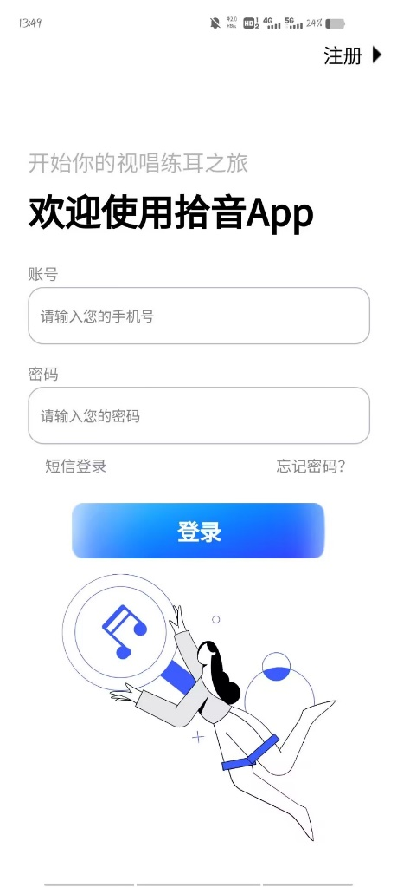 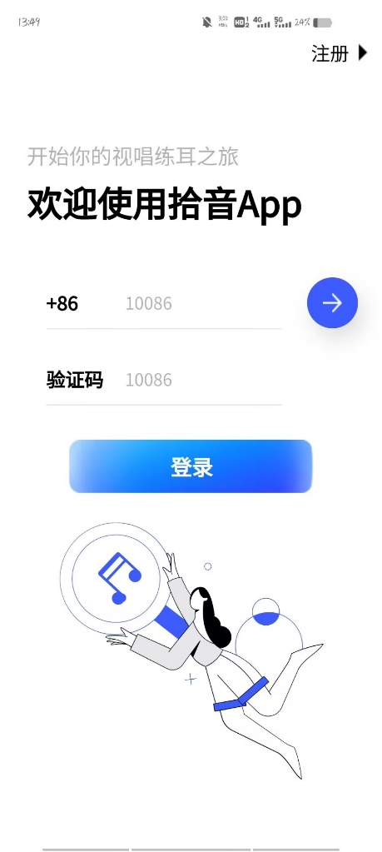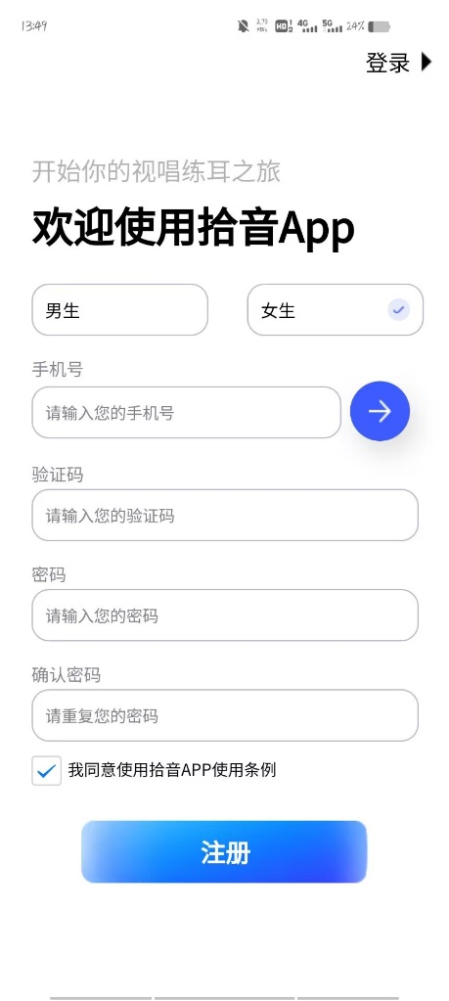

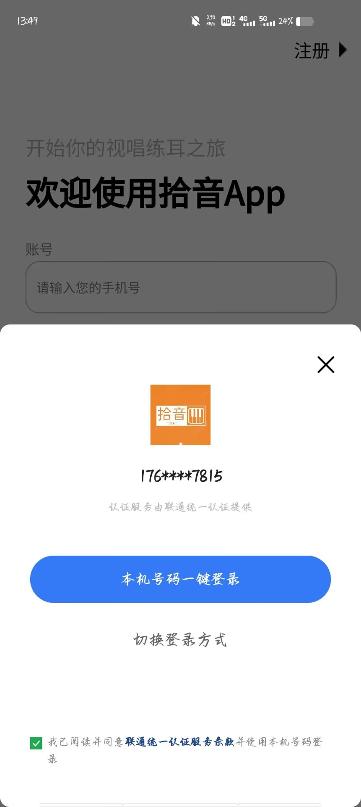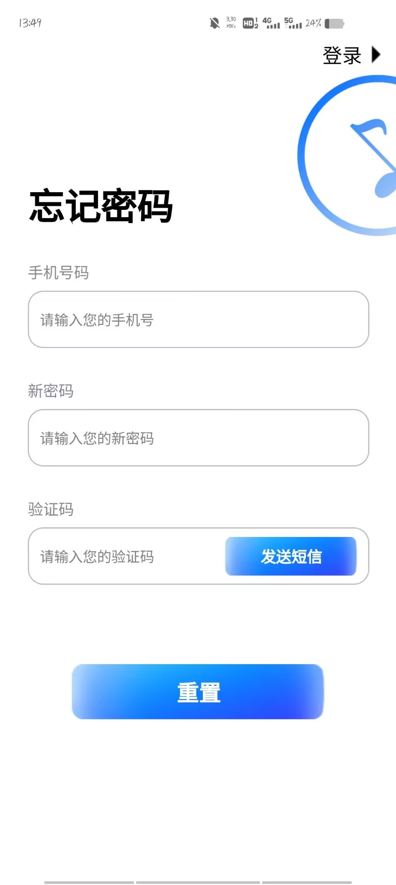

#### Main interface

The main interface includes two major functions: video teaching and text teaching. After clicking, you can jump to the corresponding interface. The user name of the current user can be displayed at the bottom, and there are jump links to three modules in the middle.

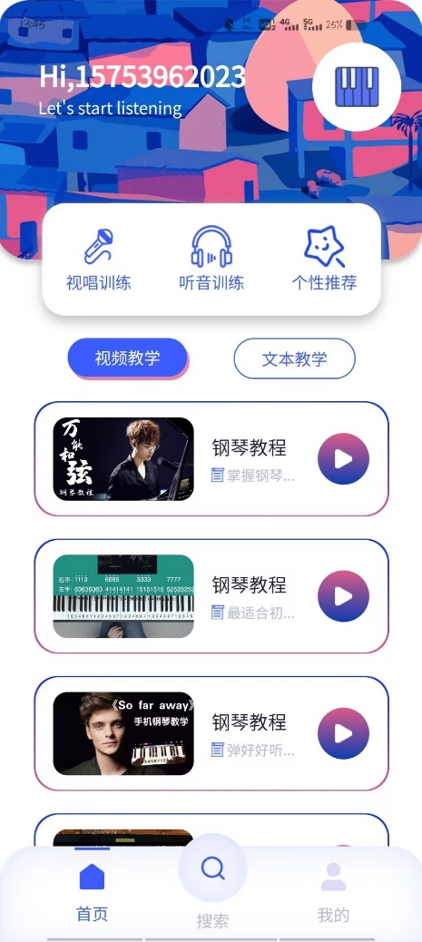 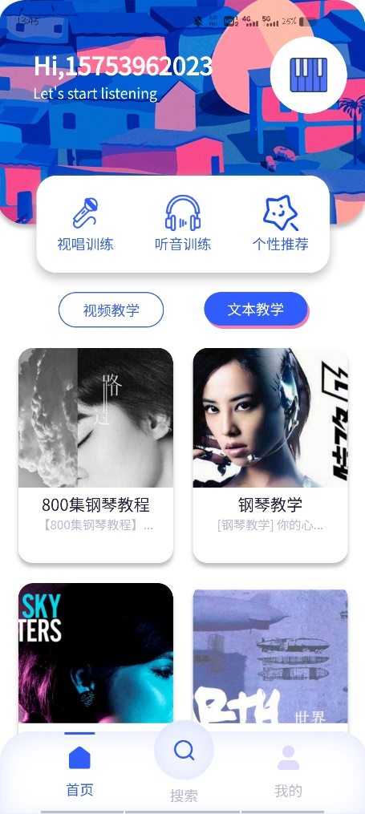

#### Sight-singing training

After entering sight-singing training, you can choose the key and time signature. Click the small icon to the right of the key selection to expand the selection. In the lower right corner is the start button. Click start to enter the details page of sight-singing training.

The details page contains a staff and two buttons. Users need to click the sight-singing button and then sing to the staff. At the same time, the app will record the audio. After the end, it will automatically analyze the audio to know whether your singing is accurate .

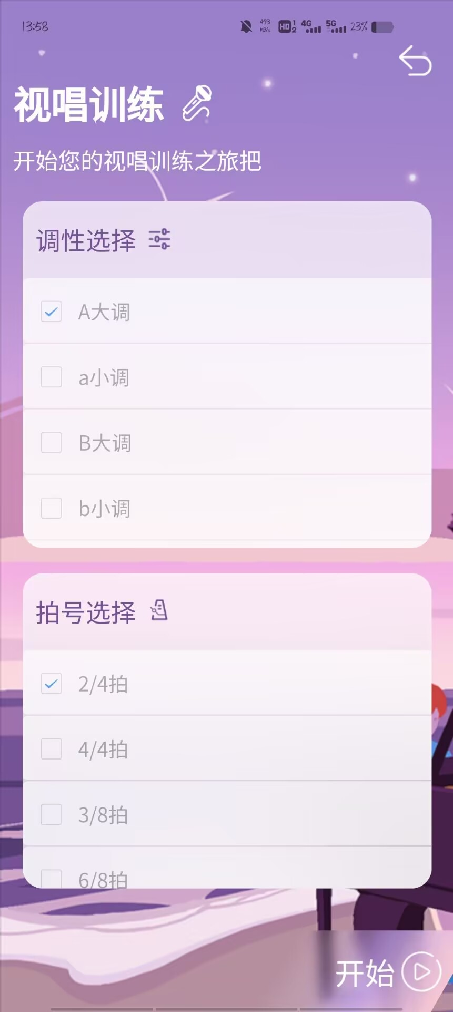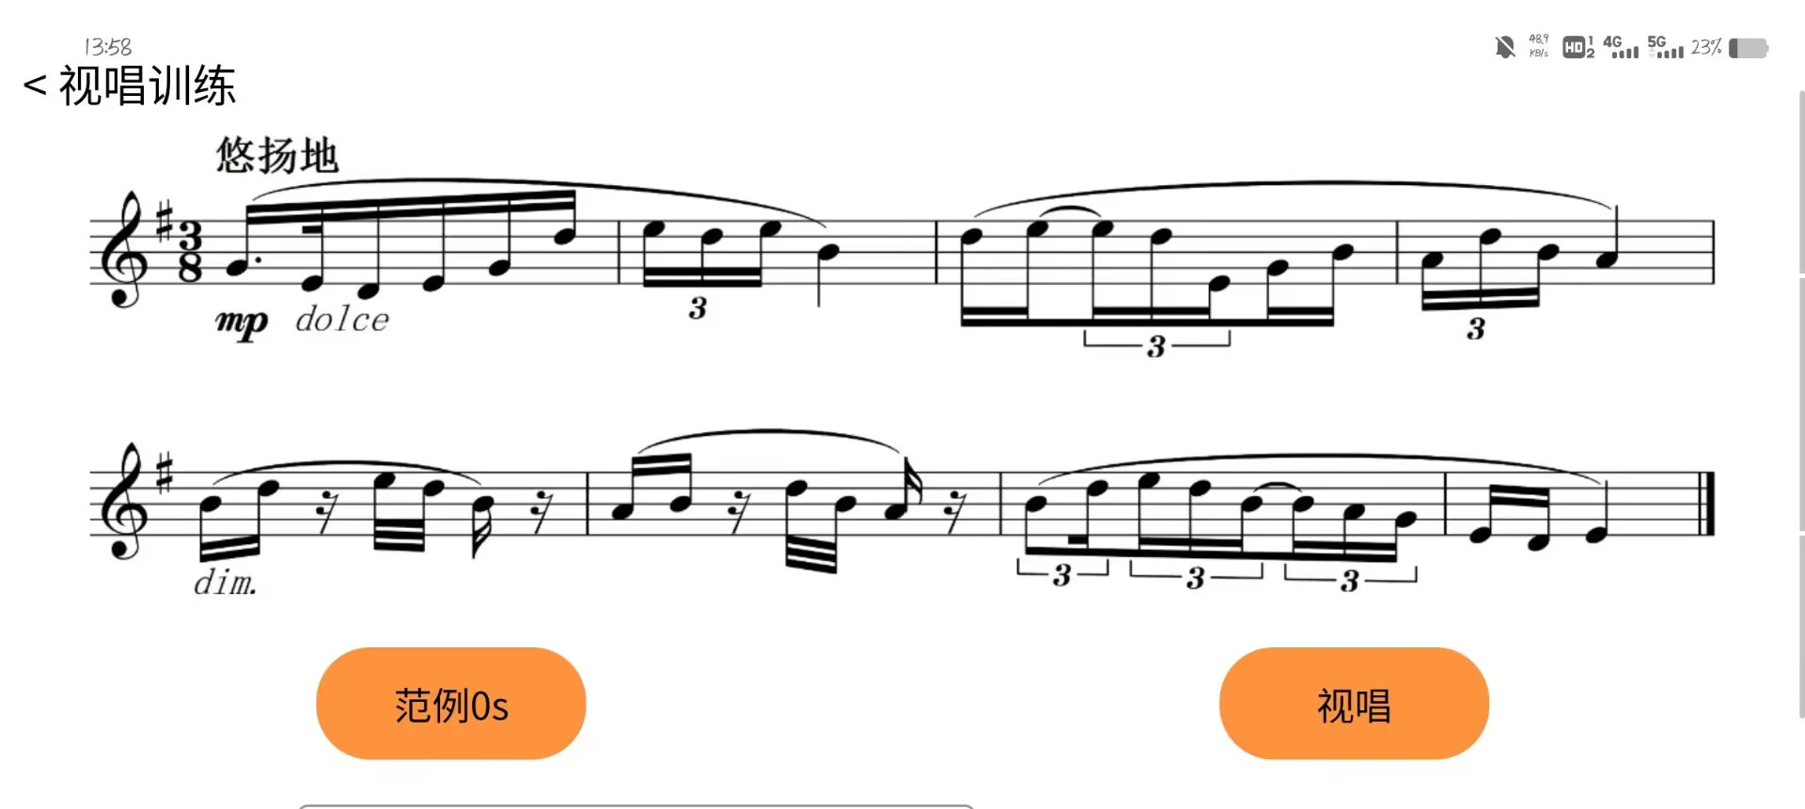

#### Listening training

First, enter the list page of listening training. There are two training methods on the list page: special training and exam testing. Special training includes various types of note training. After clicking, you can enter the training details page. Examination and test Contains the exam system. Click to enter the exam system page.

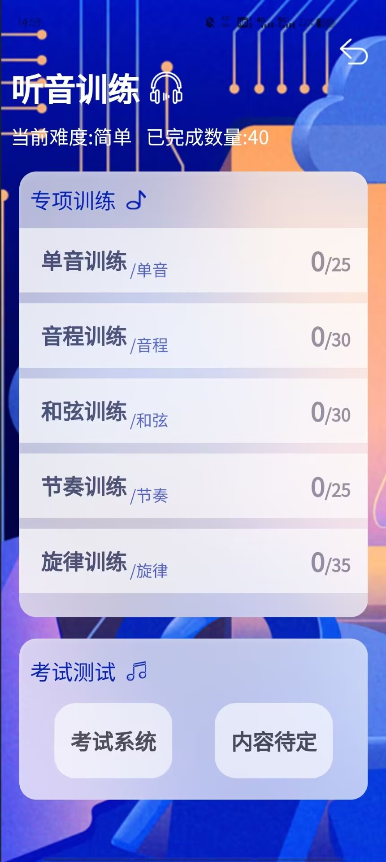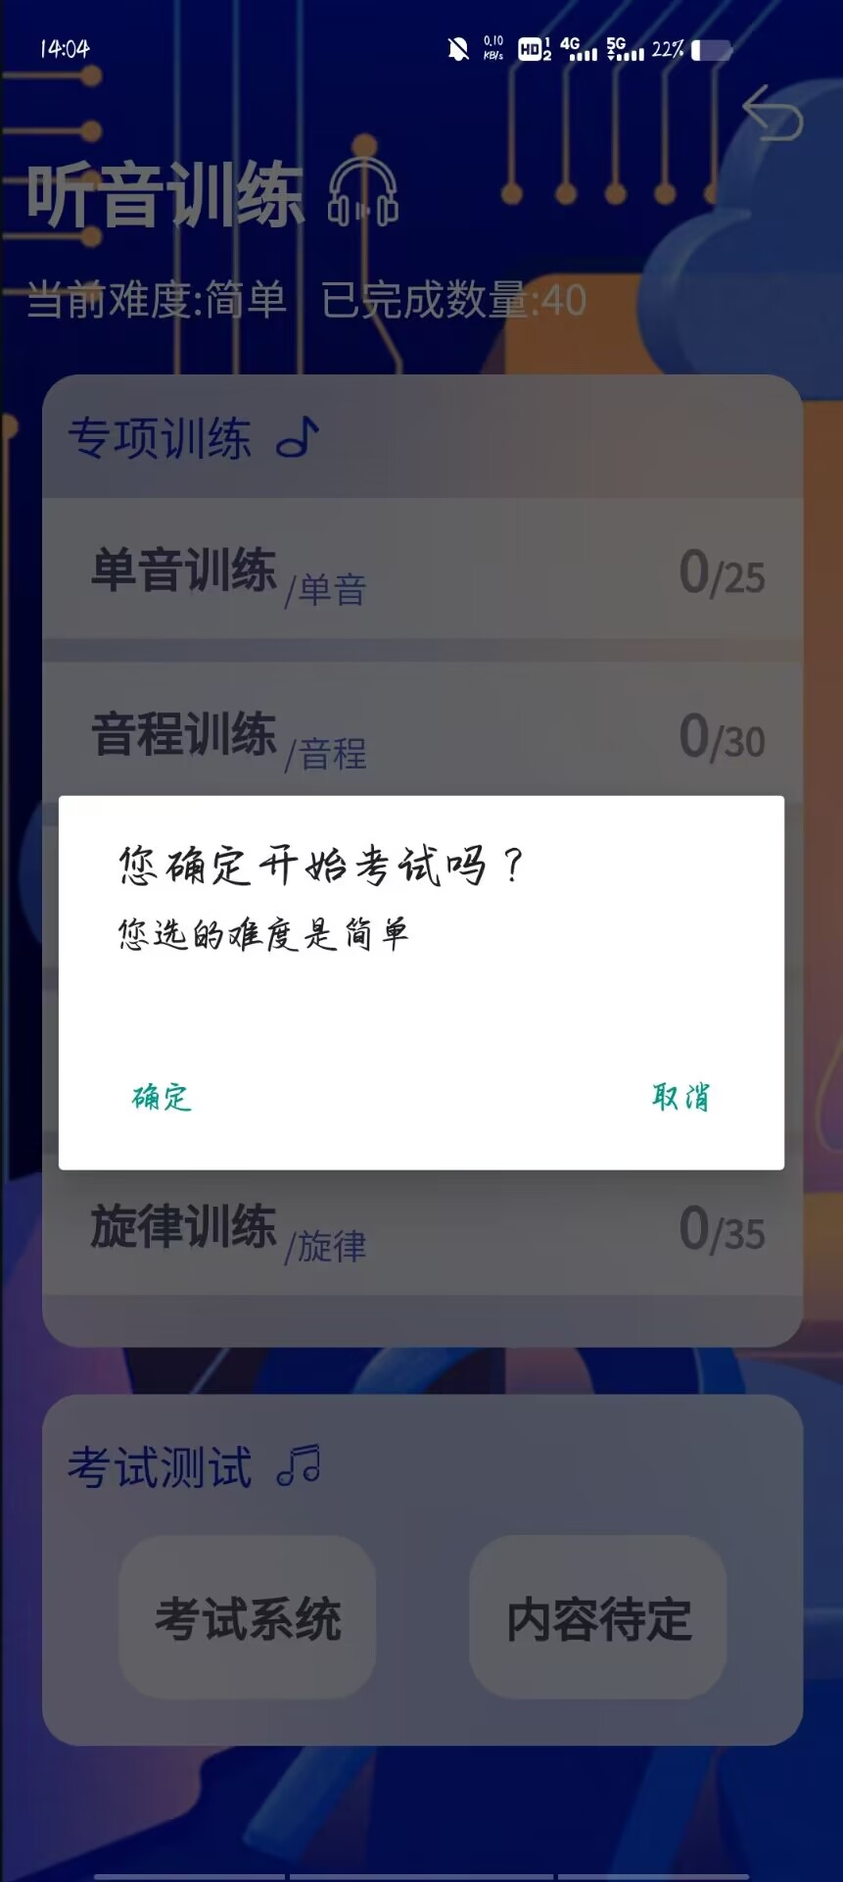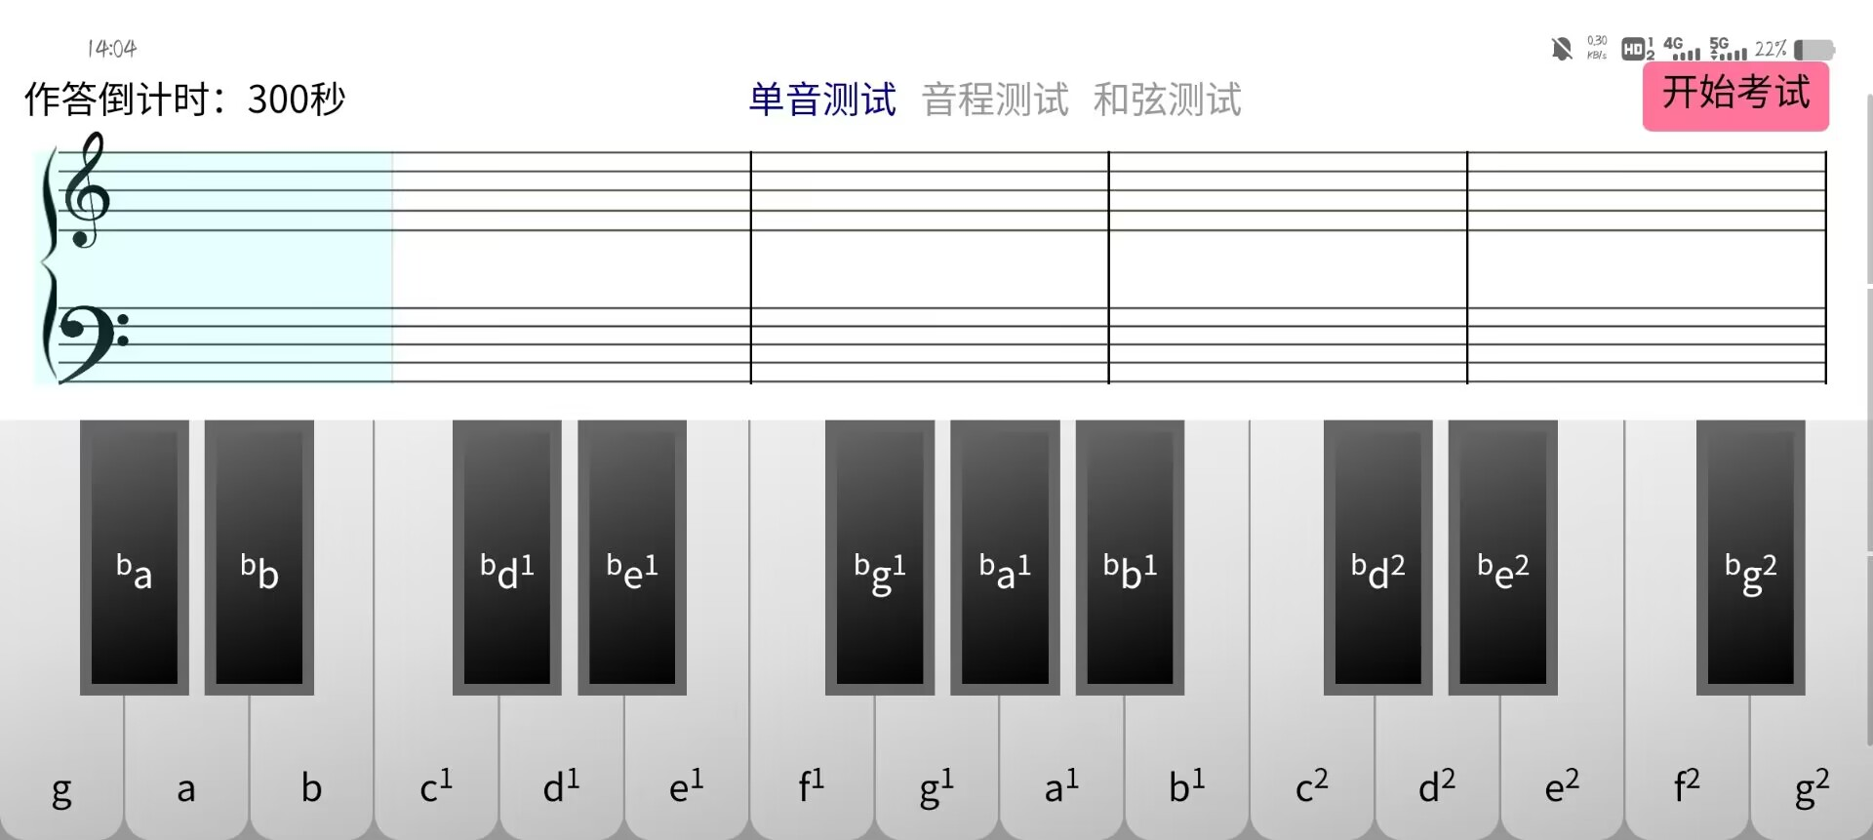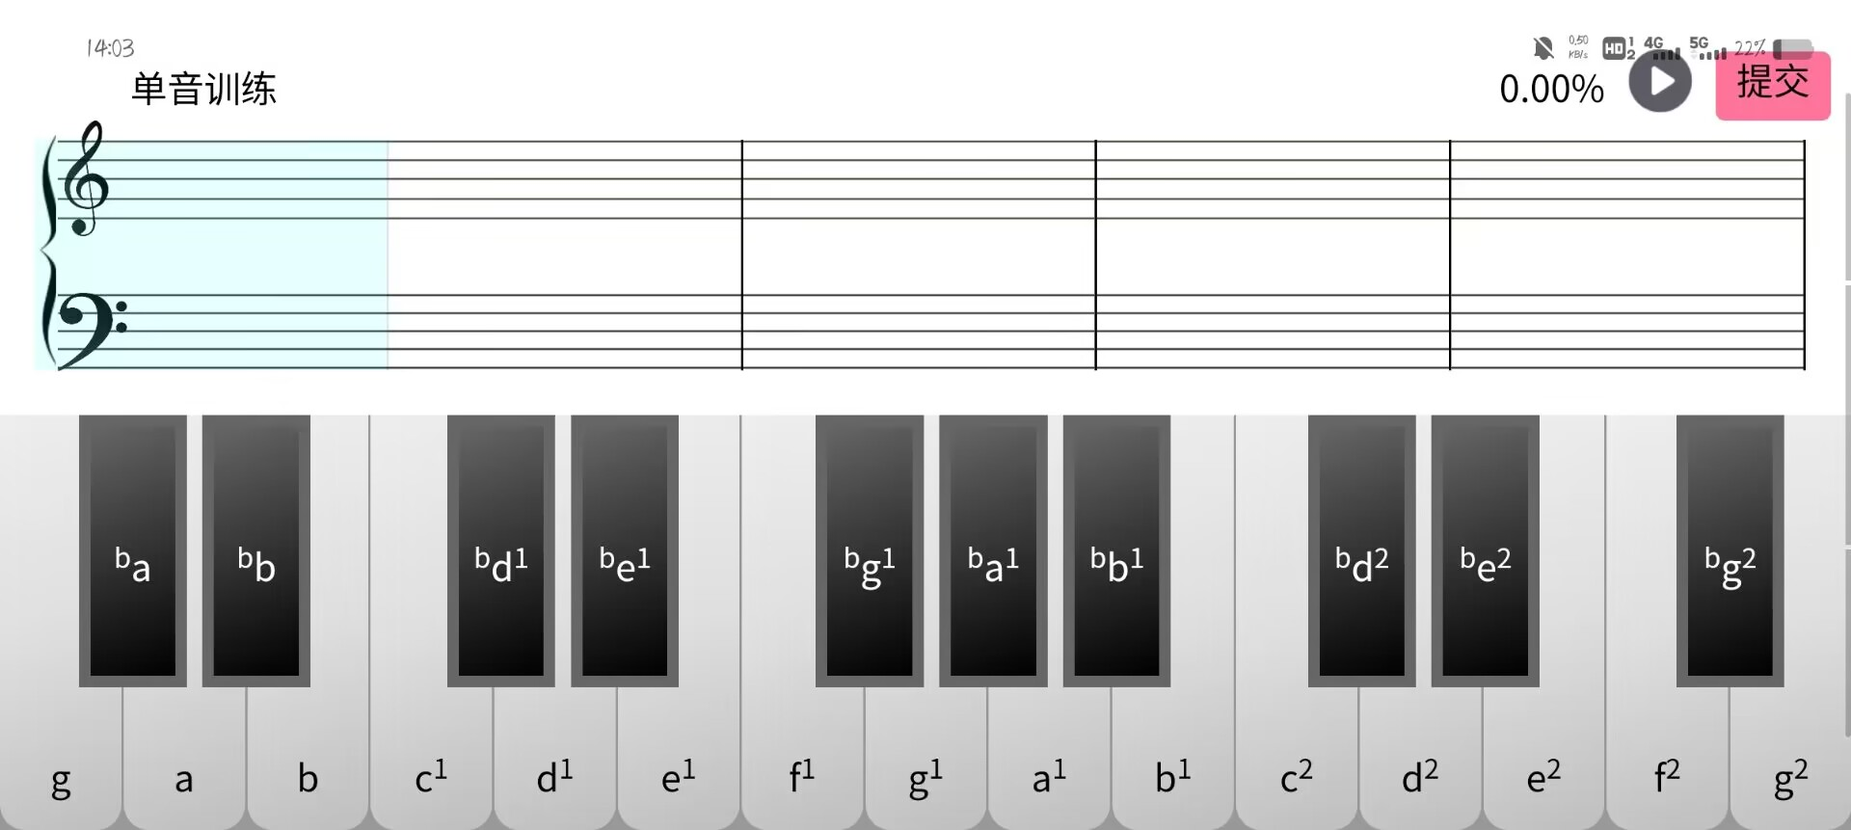

#### my page

After entering my page, there are many small functions: sign-in function, scan and practice immediately, my wrong question book function, my test record function, my music score function, privacy agreement function, and log out function .

